Smoothing

A median filter is that the amplitude value of each pixel is replaced by the median of the amplitude values within the M***×***M mask.Median filtering is a non-linear operation.

A 1-D median filter with length of 3

Input: 16 14 15 12 2 13 15 52 51 50 49

Output: 15 14 12 12 13 15 51 51 50 ...

Sharping

We use Laplacian Operator.

The first and second order derivates can be used as sharpening operators.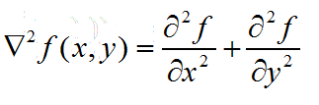



Then we can get the matrix as follow: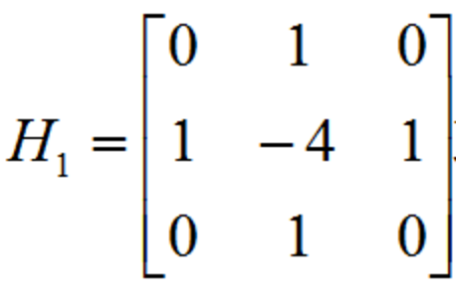

And we can also get another form: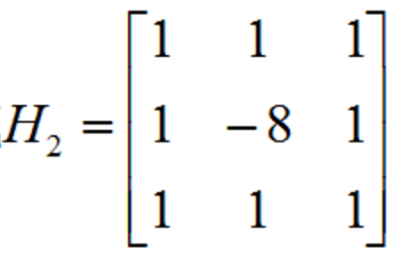

Procedure to use Laplacian operators for sharpening:

Y = Laplacian(X) + X where X is the original image,

Laplacian(·) is a Laplacian operator, that is a High-pass filter

Y is the sharpened image.

This expression can be simplified as

Y = Composite_Laplacian(X)

where the Composite Laplacian integrates the Laplacian operator with the simple summation operator.

Then the composite Laplacian Operator is: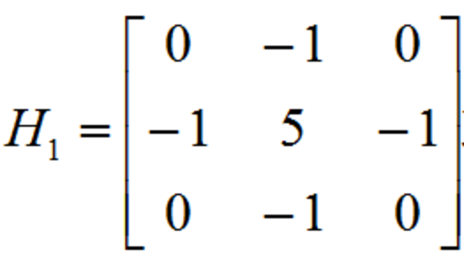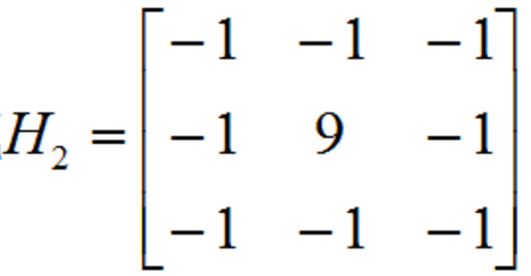

or

we use H2 as our operator.